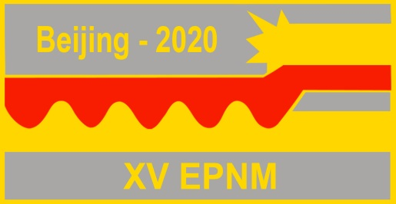
XV International Symposium on Explosive Production of New Materials: Science, Technology, Business, and Innovations (EPNM-2020)

Registration form

Given name
Middle name
Surname
Degree (title/position)
Affiliation (Institution)
Affiliation address
Telephone (office/mobile)
Email
Category of participation (regular/student)
Preferable format of presentation (oral/poster/none)
Title of the abstract and authors
I will be accompanied

